PROJECT PLANNING PHASE

Project Planning Template (Product Backlog,Sprint Planning,Stories,Stories points)
Date | 27-01-2026
Team ID | LTVIP2026TMIDS24916
Project Name | Educational Organization Using ServiceNow
Maximum Marks | 4 Marks

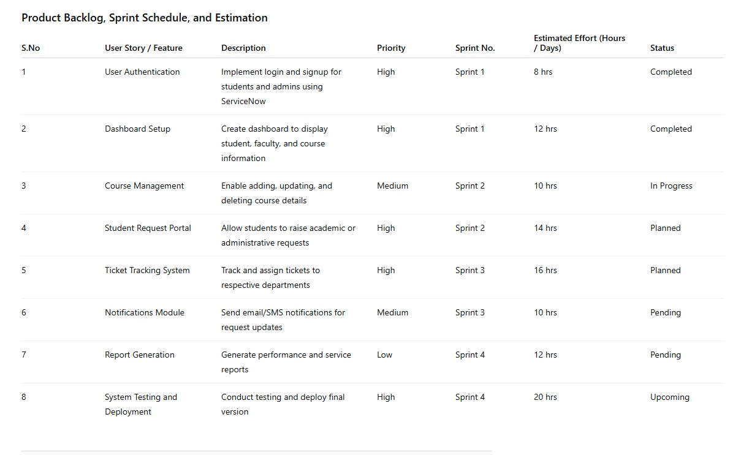
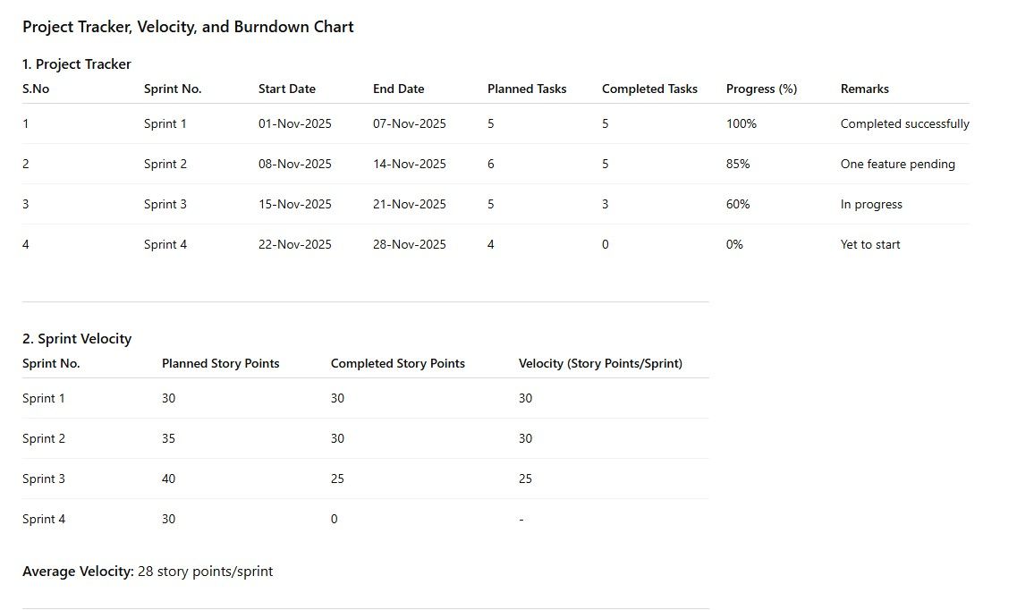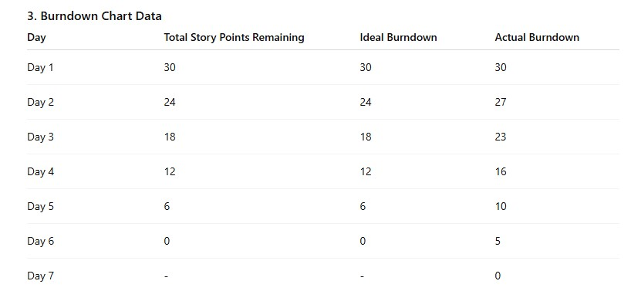
Reference:
Solved: How to find the URL to ServiceNow University (Now ...
Blog #8 - Project Case Study: ServiceNow Implement...
Automating Work Notes in ServiceNow with Hyperlink...
ServiceNow for EDU use cases / challenges / general

